**Purposes:**

1) Become familiar the use of Logger Pro software and the Vernier LABPRO data/computer interface and a variety of attachable sensors.

2) To understand some of the limitations of the use of electronic sensors and data loggers in taking and interpreting data.

3) Distinguish between mass and weight, and get a qualitative sense for the unit of a “Newton”

4) To investigate some of the consequences of Newton’s laws of motion.

5) Explore “Hooke’s Law” and use Microsoft Excel to quantify it.

Your lab instructor will provide some preliminary remarks about the lab and the physics being explored. If you have any questions or doubts about what to do, please ask the instructor for help.

**As a matter of routine, please boot up the computer as necessary and login with your student ID and password.** After the machine has finished booting up, please launch the “Logger Pro” program from the desktop icon.

**Open a blank Microsoft Word document**. You will use this to record and submit the data you have taken during this lab. At the top of the Word file, please write your name and the name of your Lab partner(s). Please work through the following activities.

**Open a blank Microsoft Excel Spreadsheet**. You will use this manipulate and model data that you have taken during the lab.

**Warm up Activity: The Dual-Range Force Probe**

**(Don’t take more than 10 minutes on this! Stop this activity and go on with the lab if you exceed this amount of time.)**

Plug two dual range force sensors into the Vernier LABPRO. Switch the sensors on the ‘10 N’ scale setting. The software should automatically recognize the two sensors. If not, the lab instructor will help you get the software up and running. The dual range force probes register the force applied to the hook. The force can be registered as a positive or negative number depending on whether the hook is pushed or pulled.

There is a small induced voltage generated when the force probe hook is displaced. The LABPRO measures this voltage and relays it to the computer. The force probe is “linear”, meaning that the signal sent to the computer is exactly proportional (in principle at least) to the force applied. If you triple the force, for instance, then you triple the signal. All sensors, however, have limits. If too large a force is applied the signal “saturates”, and the reading becomes meaningless.

The probe reads the force in units of newtons (N). A newton is about a quarter of a pound of force. To give to a feel for what a newton is, consider the following examples: A 1 kilogram mass has weight of 9.8 N. A two liter pop bottle has a mass of about 2 kilograms, so you feel a downward force of roughly 20 N when you hold it in your hand.

Notice that the probe has two ranges, 0 to 10 N and 0 to 50 N. The 50 N scale on the force probe is pretty robust. What does 50 N correspond to in pounds? Can you think of something that weighs about 50 N? Answer the question in your Word document **Question 1**: Name an item that weighs about 50 newtons.

Your instructor will explain the need to “zero” the probes. Please carefully note how and why this is done. In your Word document, answer **Question 2**: Why do you need to “zero” many electronic sensors?

Hold one of the force probes in one hand and with the other take hold of the sensor. Have some one push the collect button on the computer. Now jiggle the sensor hook. Convince yourself that the force probe is measuring the force you are exerting with your hand. Push and pull the hook to see which way records a positive force and which way records a negative force. Repeat the experiment with the other probe to convince yourself that it too is working. You should notice that the probes are registered as different colored graphs, one red and the other blue, so that you can tell the readings from the two probes apart.

Note that you can collect two different force readings at the same time, since both collect data at the same time. Repeat the experiment among your lab partners until you have all convinced yourselves that the probes read both positive and negative forces, i.e, both pushes and pulls.

You may have heard that for every force that one body exerts on another, there is another equal and opposite force acting back on the object exerting the original force. For instance, if I push on the wall with 100 lb. of force, the wall must necessarily push back on me with 100 lb. of force. This is known as **Newton’s 3rd Law**. Let’s test that here. Zero both probes and reverse the direction of collection on one of them as demonstrated by your instructor. Then take the two force probes with their hooks connected. Set the scale setting to 50 N. Hold one probe in one hand and have another person hold the other probe in their hand. Now hit the “collect” button in LoggerPro, and alternately push and pull the probes apart to your heart’s content. Try to get the readings on the computer to be different for the two probes. Let the others in the group try. Try to get different readings on the two probes as you pull or push them apart.

**Activity 1 Hooke’s Law:**

Let’s start with a discussion of how springs work. This is called Hooke’s Law. Hooke’s law says that a spring exerts a force in direct proportion to how far it is stretched or compressed. That force is exerted in the opposite direction of any force exerted on the spring. For instance, if you pull the spring down, the spring pulls back up on you, if you force it up, it pushes back down on you. To put this as a formula we would say:

(Force the spring exerts) (is proportional to) (the distance stretched or compressed).

(*F ) (= -k ) (x)*

*F =- k x*

*F* is the force of the spring

*k* is the “spring constant” that relates how much force you get for how much distance

*x* is the distance stretched or compressed, which is better called the “displacement”

The minus sign, ‘-‘ says the force is in the opposite direction to the imposed force

(meaning the spring pushes back).

Notice that this formula is like the one you learned for the equation of a straight line

*y = m x +b,* where *y* is like *F*, *m* is like k and b is zero.

Comparing forms, you can see that “*k*” is the slope of the line that relates force, *F* to displacement, *x*. Every spring has a different “*k*”. The stiffer or harder the spring is to pull, the bigger *k* is, and the steeper the slope of the force versus displacement, or *F* versus *x* line.

**Question 3**) In your open Word document answer the question: What are the units of “*k*” ? _______________

With this understanding of the spring constant “*k*”, use the following activity to measure the spring constant of the spring you’ve been given.

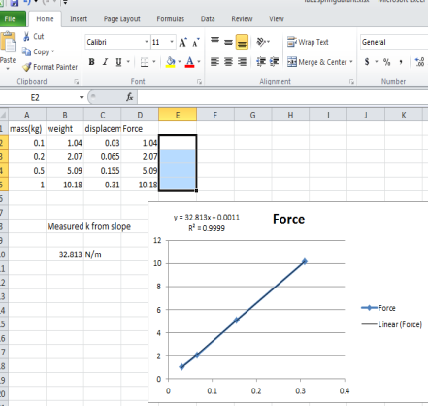

Mount one of the force probes on a ring stand so that the hook end hangs down, but so that the probe is otherwise firmly held in place. Hang a spring on the end of the force probe hook. Look under the ‘Experiment drop down menu’ on the tool bar or options menu of the LoggerPro program. Find the option that says ‘Zero’. Click on this. It zeros the probes, meaning that it resets them so that whatever condition they are in when you click that button, the computer will interpret that condition to be zero force.

Take a meter stick and record the location of the bottom of the spring. It will probably be easiest to measure it from the bottom of the force probe.

Bring up your Excel spreadsheet. Use column A to record the values of the masses that you put on the probe. Column B, C and D will be used to record the weight, displacement of the spring, *x*, and the force probe reading, *F*. Set up the spreadsheet as shown in the figure above.

You will now verify that the force probe is a “linear” device. Have ready several small masses that you can add to the spring, running from 100 to 1000 grams or 0.1 to 1 kg. (**Record the data in kilograms, not grams**! I get really tired of people being off by a factor of 1000 and asking me to solve the mystery for them!) Carefully add one mass at a time to the end of the spring as it dangles from the force probe hook. Measure the net displacement of the spring for each mass. (Net displacement is how far the spring has stretched, it is the difference between the number you measured for the location of the bottom of spring with no weight attached and the distance to the bottom of the spring when stretched.) Record the mass reading (in kilograms) in column A., record the displacement measurement (in meters!) in Column C. Record the force reading (in the lower left of the Logger Pro Screen) in column D. Repeat as necessary. Use at least 5 mass points between 0.1 and 1 kg (record the mass in kilograms). In Column B use the B2 = 9.8*A2, and copy this down the column length. This will give the weight of the hanging masses.

You should be able to quickly verify that the measured force and displacement is directly proportional to the added mass, i.e., putting a 1kg mass on the probe will give you a displacement that is 5 times longer and a force that is 5 times larger than what you got using a 0.2 kg mass, etc.

Using Excel, make a graph of the Force versus Displacement, column D versus column C. Use the plot option that makes a linear trend line through your data. The slope of that line is the “k” value of your spring. The Excel “Trend line” gives you that value. Make sure the units are right! **Copy the graph out your Excel graph and paste it in your Word document.** Record your value of “k” on beneath the figure.

**Example of Excel Analysis**

**Activity 2 – Hooke’s Law and the oscillating spring: get *k* another way.**

Remove the weights from the probe, keeping the spring on the end of the sensor hook. Hang just one mass of your choice from the end of the spring. I suggest using something between 200 and 800 grams. With the spring and mass at rest, please note the reading on the force probe:

Reading at rest: ____________ (N)

Pull the spring down A LITTLE so the mass oscillates nicely, not wildly. With the mass oscillating, turn on the data collection and collect data for about 10 seconds. You should see a very nice sinusoidal pattern on the graph such as that shown in the plot on the next page. Keep this data. You will use data in Excel later.

Please note the readings of the peak and minimum readings of the force probe. The reading taken at rest should be about half way between the peak reading the minimum reading.

We now are going to use some more advanced physics to determine the “k” value of the spring. Toward the end of the semester, you will learn that any object which oscillates in a simple sinusoidal way is called a “simple harmonic oscillator”, and that the correct formula for the motion is

y(t) = A sin( $\sqrt{k/m}$*t+B*  C **Equation (1)**

Where “y(t)” is the graph you see on the screen (In this case it is the Force acting on the mass, not the position of the mass), “A” is amplitude or peak height of the sinusoidal part of the signal and is considered to be a constant in time, “m” is the mass you have dangling from the spring, “t” is the time, “B” is just a constant to offset the origin of the sine function. Since it is unlikely that you will start your “t” at the exact moment the signal has 0 height, the constant “B” lets you adjust for that offset. “C” is an offset in Force, and should equal the force reading when the mass is at rest (and is constant).

Follow the example that your instructor will present in class: From your LoggerPro file, copy and paste the “Force” and “Time” data columns into a new Excel spreadsheet. Put your time data in column A and your spring force data in column B. There are 5 constants needed to “fit” your data and find *k*. Put a value for “A” in column D1. Eyeball an initial guess from your data. It should be half the size of the difference between your maximum and minimum data values. Put an initial guess for “k” in column E1 (1 might be a good guess). Put the value of the mass, m, in F1, (be sure to us kilograms not grams) and put a guess for B in G1 (0 is a good guess) and a guess for C in column H1 (it should be the reading taken at rest).

Now build a formula for Equation one in Column C of the spreadsheet, next to the data column in B. If my first set of data were in row 4, I would type into the cell C4 the following formula:

= $D$1 * sin( sqrt($E$1/$F$1)*A4 + $G$1) + $H$1

Copy this formula down through column C and then make a line-scatter plot of the data. It should look something like the example spreadsheet plot shown below.

You will see two lines. Vary the values of A, *k*, B and H in cell D1 through H1, until your “fit” data in column C is as close as you can get to the experimental Force data in column B. This is not hard. When you have got the numbers to fit your data, you will have the correct value of *k*.

Record the two values of k that you have measured in your Word document with correct units. If the two values are more than 5% different from one another, you have probably made a serious error along the way! Show the relative percent difference in your measured value of k by making the following calculation and record it in your Word document:

Relative error = (*k*(1st measurement) – *k*(2nd measurement))/*k*(1st measurement) x 100%

Do a “screen shot” of your Excel screen by pressing the “PrtSc” key and paste the image into your Word document to verify your successful implementation of the line fit.

A very similar example of this analysis is shown in the figure below.

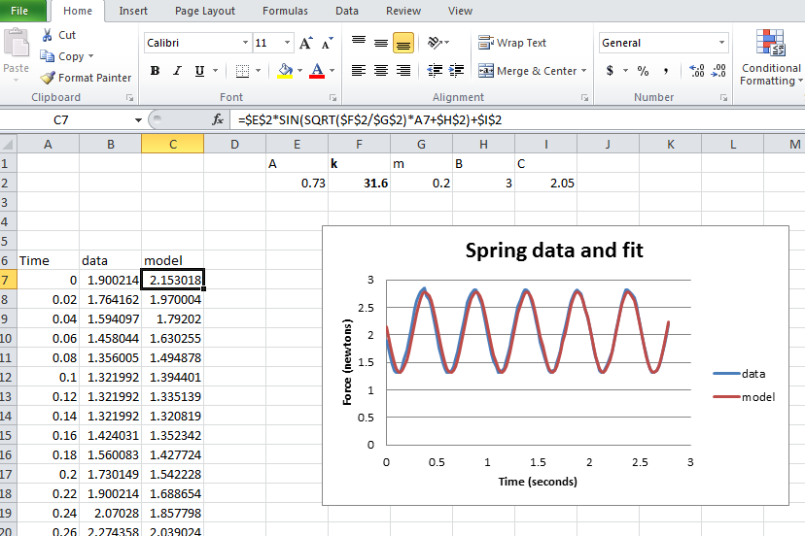When the class has got to this point the instructor will show you how to characterize the “goodness” of the fit by using various statistical functions in Excel. Feel free to jot down a note or two. Please pay particular attention to the idea of “deviates” and their squares, and the “root mean square” introduced by the instructor, and the “R-squared” value to a fit. You will be using these definitions nearly each week of the course in which you test data. To calculate a goodness of fit “by hand”, you would square the difference between the data and model, and sum them, and then divide by the number of points and take the square root. The closer this number is to zero, the better the fit. (In the figure to the right, the command D7 = (C7-B7)^2, would be copied into all the cells in which there is appropriate data. Then an appropriate cell would be defined for the as the square root of the sum of all the D-cells, divided by the number of cells.)

**Physics Analysis and Understanding**: Let’s consider some things about what the graph means. Clearly, even obviously, the mass dangling from spring does not change as the spring oscillates. So if the force probe simply measured weight, then the reading should not change, right? But the probe does register forces. So why does the reading of the graph change as the spring and mass oscillate? Please commit yourself to the physics of the situation by first discussing the situation with your partner then then **writing out an explanation for the two of you beneath your graphs in your Word document**:

*Why does the reading on the graph change? Explain to the best of your ability why the force reading should varying between a number smaller than the item’s weight and larger than the item’s weight. (A clever student should make use of* ***Newton’s second law and consider the implications of the accelerations experienced by the mass****!)*

The correct explanation is posted as a note on the Canvas website. Please check there if you’d like to check your understanding. A core understanding of Newton’s second law is needed to understand the correct reason. It is not hard, but it is also not necessarily obvious.

**Activity 3**: **Review of Spreadsheet Calculus and Kinematics.**

Your spreadsheet data of time and force in columns A and B can be used to explore the calculus of kinematics. That is, the velocity is the time derivative of position and the acceleration is the time derivative of velocity. Or, doing it the other way, if you have the acceleration, you can integrate it to get the velocity. If you have the velocity, you can integrate it to get the position. The record of the force data you have is a measure of the acceleration, since from Newton’s second law, a = F/m.

For this calculation, make a new calculated column in column D of your spreadsheet. Define D7 as

D7 = (B7-$I$2)*(A8-A7)/$G$2 + D6, Where $I$2 is the “offset” constant force of the hanging weight. You have to subtract this off, because you want the force exerted the spring, not the weight of the mass! Then we divide by $G$2 because $G$2 contains the value of your mass, m, so that (B7-$I$2)/$G$2 is the acceleration, a(t), of the mass at that point. Copy the definition in D7 down the length of the column. Column D is now a measure of the masses velocity, v(t)! The next step would be to integrate the velocity to get the position. You can do this by defining E7 = D7*(A8-A7)+E6. This is the same as saying x(7) = v(7)*dt + x(6). Copy this definition down the column. Column E now as a record of position versus time, y(t)! See the figure below and examine how I’ve implemented it. I’ve put ‘initial values’ in the positions D6 and E6 for plotting use. For convenience of plotting, I’ve copied the data from columns A, B, D and E into columns G, H, I, and J, just to make the plotting easier. Examine the figure below to see the result.

You should try the same thing. Please pay extra careful attention to the instructor when he or she tells you about adjusting the constants $G$2 and $I$2. You will probably need to do this to get the quality of result shown below.

Please note the following physics of the resulting integrations: 1) The position and acceleration are 180 degrees “out of phase”! That is, when the acceleration is the largest positive value, the position is the most negative, and visa versa. Also note that the velocity is out of phase by 90 degrees. That is, it has its maximum values when the position and acceleration are both crossing zero! This turns out to be the hallmark behaviors and ANYTHING that oscillates harmonically.

Here’s the secret:

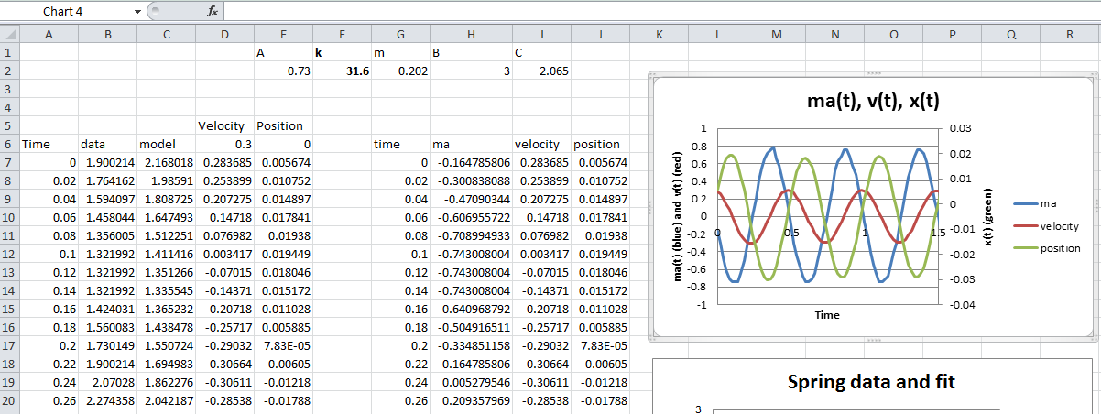The acceleration goes like a(t) = cos( t). The velocity, which is the integral of the acceleration, must go like the sine function because the integral of cos( t) is sin( t)/  . Likewise, the position, being the integral of the velocity must be the minus cosine, because the integral of sin( t)/  is -cos( t)/2. Our simple calculations from the *real* data we collected, verify this theoretical and mathematical result:

If a(t) = A cos( t)

then v(t) = A sin( t)/

and  x(t) = -A cos( t)/2

Take a screen shot of your spreadsheet data and plot results and paste it into your Word document.

Make sure your name and your lab partner’s name is on the document.

Include the Day and Hour of your Lab.

Print the document to the printer in PS 108. TURN THIS IN. It constitutes your lab report for the day.